Before diving into the implementation processes of the main solution approach, one should compare the advantages and the disadvantages of different possible solution methodologies in order to make a better decision on both the economical aspect and the efficiency, complexity, etc. In the case of this pre-defined project, there are many possible topologies that can be used as a solution approach, but when it is thought by means of the components’ availabilities, circuits’ complexities, additional costs, sub-systems, etc. the total number of the possible solution approaches decrease to four which are listed as,

1. Three-Phase Full-Bridge Diode Rectifier
2. Three-Phase Fully Controlled Thyristor Rectifier
3. Single-Phase Fully Controlled Thyristor Rectifier
4. Dimmer

Those four topologies listed above are the most widely used designs in power conversion applications and their selection carries vital importance in the design procedure of the defined project’s solution. In order to give a slight insight to the reader, the operational principles of the given four topologies are going to be briefly explained in this part.

In the topology of “Three-Phase Full-Bridge Diode Rectifier” there should be six diodes or one three phase diode rectifier IC at the input stage of the circuit which are used in the rectification process of the AC input signal. By the gate drive of a switch with a generated PWM, this input signal is transmitted to the output stage as ripple-free as possible by the virtue of L-C filter connected at the output stage of the circuit. If one changes the duty cycle of the generated PWM, the switching is changed accordingly and therefore the output voltage is controlled.

The solution approach of “Three-Phase Fully Controlled Thyristor Rectifier”, needs six thyristors which should be implemented and the drive operation of the gates of each thyristor by impulse gate currents supplied from a generated PWM with 120 degrees phase difference between each of the gate currents of each phase. The output signal can be changed according to the firing angle of the thyristor which can supply a user the necessary output voltage.

When “Single-Phase Fully Controlled Thyristor Rectifier” is taken into consideration, the same principles of Three-Phase Fully Controlled Thyristor Rectifier shall be applied. The only difference is the thyristor numbers which is four and the gate drives of the thyristors which should have 180 degrees phase difference between each phase.

“Dimmer Circuit” is a topology which has diac, triac, capacitor and two resistors where one of the resistors are a POT to change the time constant of the capacitor to supply the desired output voltage to the load.

### Three-Phase Full-Bridge Diode Rectifier and Buck Converter (Selected)

This topology is composed of a “Three-Phase Full-Bridge Diode Rectifier” integrated circuit in order to take a DC kind of output at the output stage while a three-phase AC signal is applied to its input, a DC-Link capacitor to decrease the ripple at the output stage of the rectifier as much as possible and a buck converter topology which is used in order to decrease the input DC signal to lower levels by an internal switching components like IGBT or MOSFET, a freewheeling diode and an L-C configuration at the output stage of the converter.

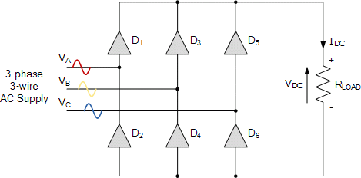

*Figure 1: Circuit schematic of 3-Phase full-bridge diode rectifier*

In order to control the switching frequency and switching period (conduct and cut-off period) of the switching component (an IGBT or a MOSFET) a PWM signal should be applied to the switching component’s gate from an analog controller or a microcontroller at the desired frequency. Besides, since the generated PWM is a very small voltage -like 5 Volts- and this small voltage circuitry should be isolated from the high voltage side from where the main power flows. In order to isolate the low-voltage circuit from the high-voltage side, an optocoupler or an isolation component shall be used in the design. As it can be clearly observed, there are several components that should be included in the designed solution.

From the point of view of the above information, the advantages and the disadvantages of the “Three-Phase Full-Bridge Diode Rectifier and Buck Converter” topology can be listed as,

1. **Advantages**
   1. *Easy controllable switching frequency to control the output ripples*
   2. *Simple speed control with only one switching device and an analog PWM generator or a controller*
   3. *The freedom of the design of output L-C filter by which the output ripples are controlled*
   4. *Relatively higher efficiency up to 94% according to the desired output voltage*
2. **Disadvantages**
   1. *The number of the components are relatively higher when compared to other design alternatives*
   2. *Due to higher components number, it results in relatively higher costs*
   3. *Any mistake in the design procedure or the operation may blow all the components of DC-DC converter which might yield to a higher cost and longer implementation processes*
   4. *It has high switching losses if a high kHz switching frequency is used*
   5. *If the inductance value of the converter is chosen as a large value to decrease the output ripples, the converter gets into discontinuous conduction mode easier which yields to higher output voltages which may harm the DC motor being driven.*

### Three-Phase Fully Controlled Thyristor Rectifier

The circuit schematic of three-phase fully controlled thyristor rectifier can be seen in Figure 3. This topology is composed of six thyristors utilized for 3 phase rectification purposes. A control circuit is required to feed current pulses to the gates of each thyristor with specified firing angle. Average output voltage can be controlled by means of firing angle of current pulse to the thyristors.

Thus, this topology provides a simple controllable operation without the need of a buck or boost converter to regulate the output. Also compared to other topologies, a larger output voltage with a small voltage ripple can be achieved even without DC side capacitor thanks to the controllable operation. Two quadrant operation is possible in this topology thanks to the inverter mode of thyristors. For achieving four quadrant operation, two parallel three phase thyristor rectifier can be used.

The biggest drawback of this topology is the synchronization problem. Basically, the control circuit that generates current pulses should be in synch with the 50 Hz 3 phase AC input in order to provide desired operation. This results in a relatively complicated control circuit design. Furthermore, in terms of power considerations, the delay caused by firing angle results in lower power factor (PF) and discrete power factor (DPF) for smaller output voltage levels compared to diode rectifiers. Thus, reactive power effects should be considered carefully for this topology.

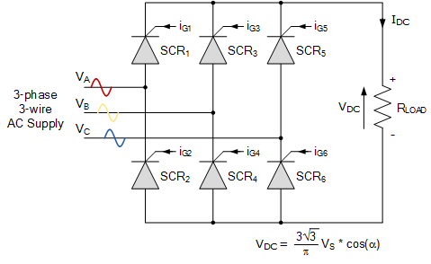

*Figure 2: Circuit Schematic of 3-phase full-bridge thyristor rectifier*

From the point of view of the above information the advantages and the disadvantages of the “Three-Phase Fully Controlled Thyristor Rectifier” topology can be listed as,

1. **Advantages**
2. *Higher output voltage thanks to three phase input*
3. *Lower output voltage ripple is achieved so that filtering is not necessary at the output*
4. *The efficiency is higher compared to the other rectifiers*
5. *Two quadrant operation, inverter mode, is already possible without the need of a parallel circuit.*
6. **Disadvantages**
7. *A relatively complicated control circuit is required to achieve synchronization with AC input*
8. *Lower power factor (PF) and discrete power factor (DPF) for smaller output voltage levels*

### Single-Phase Fully Controlled Thyristor Rectifier

The circuit schematic of single-phase fully controlled thyristor rectifier can be seen in Figure 3. This topology is composed of 4 thyristors utilized for single phase full wave rectification purposes. A control circuit is required to feed current pulses to the gates of each thyristor with specified firing angle. Similar to three phase fully controlled thyristor rectifier, average output voltage can be controlled by means of firing angle of current pulse to the thyristors.

However, for this topology output voltage level is lower than the three-phase case, therefore a boost converter might be needed in order to drive the DC motor properly in preferable levels. Also output voltage ripple is higher due to single phase source in this topology. Thus, three phase fully controlled thyristor rectifier is more preferable over single phase fully controlled thyristor rectifier.

The major drawback of this topology is that the gate signals of thyristors used in the circuit need to be controlled properly as it was the case with three phase fully controlled thyristors rectifier topology. However, control circuit is relatively simpler than the control circuit in three phase fully controlled thyristor rectifier topology due to the fact that less pulses are needed in a cycle. Furthermore, it should be noted that large harmonics are present in the input current in this topology type.

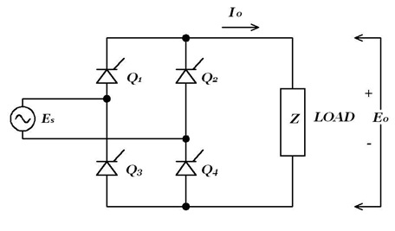

*Figure 3: Circuit schematic of single-phase full-bridge thyristor rectifier*

1. **Advantages**
   1. *Simpler control circuit compared to three phase fully controlled thyristor rectifier*
   2. *A cheaper solution relative to others*
   3. *Two quadrant operation, inverter mode, is already possible without the need of a parallel circuit.*
2. **Disadvantages**
   1. *Still a complicated control circuit is required to achieve synchronization with AC input*
   2. *Lower power factor (PF) and discrete power factor (DPF) for smaller output voltage levels*

### Dimmer

One of the options that is taken into consideration is the Dimmer topology. It is not an option provided in the project definition, but due to its simplicity, that topology is selected as a possible solution approach. After conducted researches, it is understood that the dimmer circuit comes with some benefits when compared to its alternatives. As it was explained in Chapter-I, the circuitry has diac, triac, capacitor and two resistors where one of the resistors are a POT to change the time constant of the capacitor to supply the desired output voltage to the load. In order to provide clearer information to the reader, the operational principle of the circuit will be analyzed. “Figure1” shows the circuit diagram of the Dimmer circuit. In the application, light bulb will be implemented as the load which is the DC motor in the project. BTB12 represents the TRIAC and DB3 is represents the DIAC. As it can be interpreted from the graph, it is a compact design with fewer components. In this part, TRIAC and DIAC will be explained briefly. Then; the roles of resistor, capacitor and potentiometer will be explained.

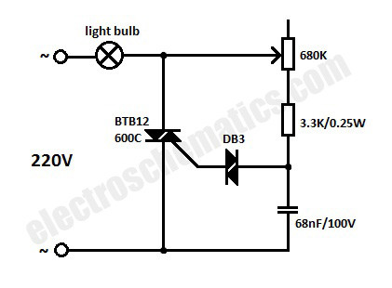

*Figure 4: The Schematic of the Dimmer*

“Figure 4” shows the I-V characteristics of TRIAC. It is as if an I-V graph of a thyristor where 1st quadrant is reflected to 3rd quadrant symmetrically. Indeed, it is true. A TRIAC is composed of simply two thyristors connected back to back and they are fed from the same gate connection. As the graph suggests, TRIAC is a 1st and 3rd quadrant device. This means that it can be opened with a negative current as well in which case it will conduct in reverse direction due to symmetry. Hence, there is no anode or cathode in TRIAC.

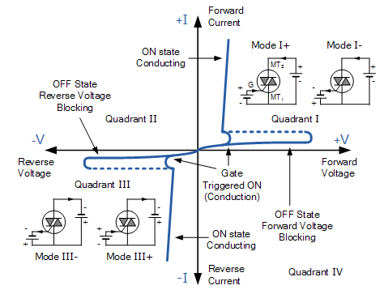

*Figure 5: The I-V Graph of the TRIAC*

“Figure 3X” shows I-V graph of a DIAC. As in previous case where TRIAC has been likened to a symmetrical thyristor, DIAC looks quite like a symmetrical diode. Actually, it is a double diode connected back to back. This gives an I-V graph symmetric with respect to origin. Only difference is there is a pulse in IBO-VBO point unlike a diode. Advantage of this characteristic is that it opens up at a relatively high voltage whereas a diode opens up at 0.7V. This can help with stability as the component does not open and close in an unstable way. Break-over voltage (VBO) is usually in an amount of 30V. Since both TRIAC and DIAC are 2-quadrant components, they are used together in this topology to exploit the advantages of 2-quadrant operation.

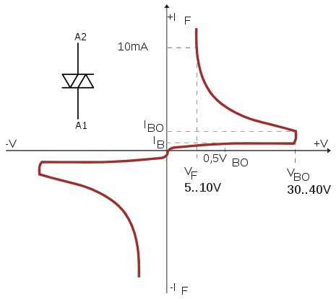

*Figure 6: The I-V Graph of the DIAC*

Apart from TRIAC and DIAC, there is also an R-C branch in dimmer. Main role of this branch is to adjust time constant. Capacitor is placed between one end of DIAC and the ground to facilitate voltage variation to be continuous and smooth. The embedded resistance plays a role to prevent time constant to go to “0”. If that resistor wasn’t placed, time constant would be varying in the range of zero to maximum value of RP*C. With this resistor, it will vary in the range of $R.C$ to $\left(R+R_{P}\right).C$. Eventually, TRIAC will not open at “0” degree as there is always a time constant bigger than “0”. The advantages and the disadvantages of the Dimmer can be listed as,

1. Advantages
   1. Relatively small number of components
   2. Lower cost
   3. Compact design availability
   4. Lower Frequency drive availability
2. Disadvantages
   1. Higher Output Ripples